Microprocessor: Lights, Music & LCD

CS 594/594L Fall 2018 EECS/WSU

Project Report (IEEE Format) **Group#: 1**

Aidan Jude

Aaron Hohler

Peter Vu

Mubasshir Karim

***Abstract*—This report explains how to create and design a microcontroller system that sends digital inputs based off of audio waves to LEDs and LCD displays to inform the user of the audio title and symphony. The report discusses the following in this order: Introductions, Literature Review, Proposed Theory, Research, and Conclusion.**

# Introduction

The possibilities of microcontrollers are essentially endless, which goes to show how powerful they truly are and also how we can continually grow in our various applications of them. They are used in automobiles, telephones and today’s smart watches that are worn by many. Microcontrollers are basically small computers that are allow for implementation at a small integrated level due to their cost effectiveness and versatility. What the microcontroller consists of is a single integrated circuit with programmable inputs/outputs, memory and of course a processor. Though microcontrollers are not as powerful as an actual computer, they are smaller, cheaper and can essentially do any task you would like for it to do. Hence, we, as a group, wanted our microcontroller to synchronize music with lights while also having an LCD display. Our solution utilizes two microcontrollers and provides the means to turn any dull gathering into one that is resounding with music and coordinated color.

# Literature Review and Survey

## *Designs and Concepts*

We did heavy research and concluded by surveying three different designs for our literature review. Vamsikurre’s design, Juveria_rk’s design, and a third design using a MSGEQ7 IC rounded out our designs and concepts. Vamsikurre’s design used a MSGEQ7 IC in a fairly similar manner to that of the third implementation found online, but required line input reduced its portability. Juveria_rk’s used an external microphone to detect sound and used individual LEDs instead of a LED strip. The third design used an LED strip and split audio into seven different channels for the respective LEDs. We took different design elements of each of the three different examples that fit our vision and combined them into one new design. Vamsikurre’s design implements an LED strip, MSGEQ7 MOSFET board, and a 3.5mm audio jack seen in Figure 1. The audio jack and clumsiness of the LED strip makes this design less portable than others. Also the use of the MSGEQ7 board adds cost the project. However, it is a more reliable setup with the use of a direct sound input [1].

FIGURE 1. Vamsikurre’s Design

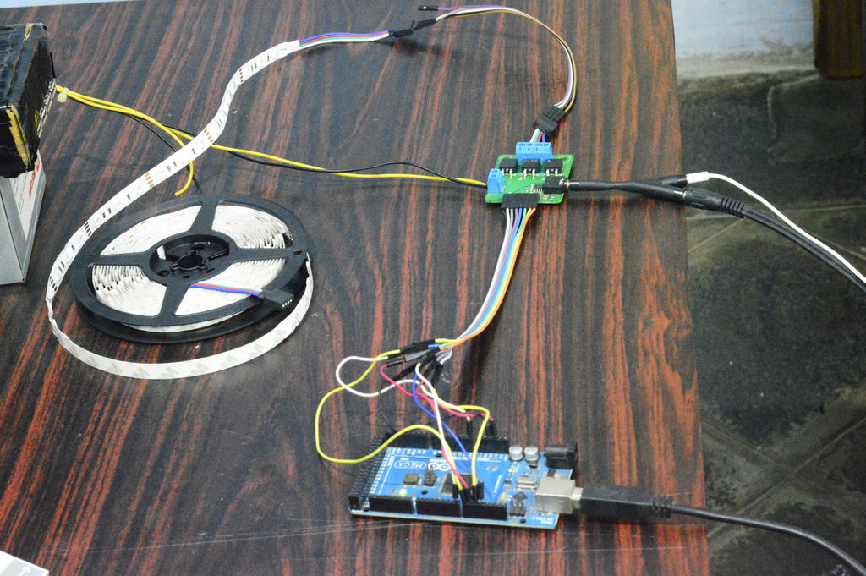

TABLE 1. Components

|  |  |
| --- | --- |
| **Vamsikurre’s - Party Lights** | |
| ***Hardware*** | ***Software*** |
| MSGEQ7 | Software provided using serial inputs and outputs. |
| Arduino |
| LED Strip |
| 3.5mm Audio Jack |
| 12v & 5v Power  (LED Strip, Arduino) |

Another design from Juveria_rk’s on Intractable is one of the simpler designs which allows for changes and improvements. This design does not use the MSGEQ7 IC but rather an external microphone to detect the sound which makes it much more portable and adaptable to many different scenarios and situations. This design however chooses to use individual LEDs instead of a multicolored strip. Despite this, interchanging the individual LEDs for a multicolored strip would not be difficult. However, utilizing a microphone was found to decrease the quality of the lighting coordination due to the sound quality being limited to that of the limits of the microphone. For example, if we were to implement a design that utilizes a microphone, and the surrounding area were to be flooded with people and differing tones of voices, then the lighting coordination would be affected due to the decrease in sound quality received and processed by the microphone and subsequently the microcontroller. [2]

FIGURE 2. Juveria_rk design

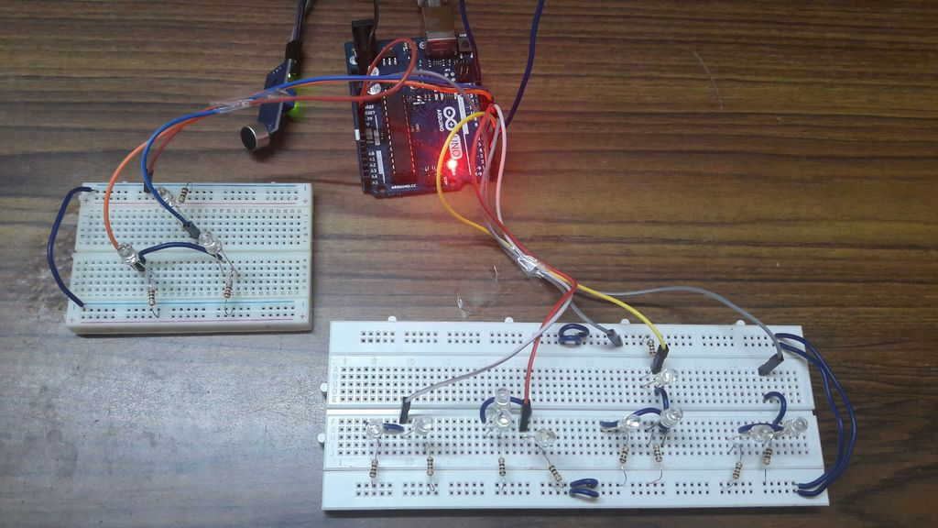

1. Components Requirements

|  |  |
| --- | --- |
| **Juveria_rk Arduino Design** | |
| ***Hardware*** | ***Software*** |
| 5mm LEDs | Arduino Software |
| Resistors |
| Microphone Sensor |
| Arduino Board |

A third design also uses a multicolored LED strip but instead of a line in connection it uses a microphone. Like the first design, it uses the MSGEQ7 IC to split the audio input into 7 channels which we can use to control the LEDs, but this component adds to the overall cost of the embedded system design and limits the possible scalability of the design since we would be limited in further funding due to increased initial component cost. [3].

FIGURE 3. MSGEQ7 IC

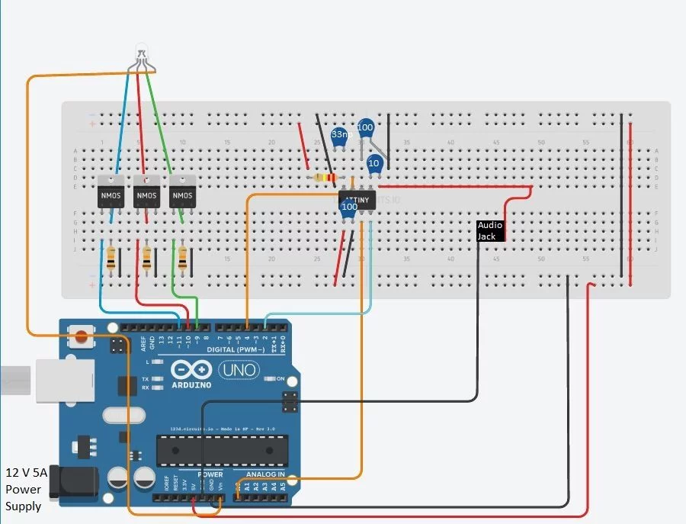

1. Components Requirements

|  |  |
| --- | --- |
| **Avni’s Arduino Design** | |
| ***Hardware*** | ***Software*** |
| Transistors | Arduino Software |
| RGB LED strip |
| Resistors |
| MSGEQ7 IC |
| Microphone Sensor |
| Arduino Board |

## *Programming and Scripting*

For our design, we used an Arduino which is programmed in C to process our LED light display. The use of the ‘Process’ open source software, we will be able to effectively process the music being played on any computer or device with USB connection and convert this processed music to serial messages which will then be communicated to the microcontroller and trigger the proper LED and/or voltage to the DEMOEM pin. One of the available libraries which will aid in this process is the Minim Java Sound library which analyzes audio signals and processing which will allow our Arduino to be able to accept input audio and response accordingly via LEDs. This library allows many different types of audio processing for example, hi-hat, snare, etc. which will allow us to have a huge variety of sounds to response to instead of a generic on/off for the LEDs for sound on/off. However, we will be doing a good portion of the programming ourselves, which will make our product unique, and allow for very personalized implementation.

## *Challenges*

There were a couple of things that challenged us and that was the programming and the scripting of the LEDs and LCD display to be interactive with the input. Also, the ability to either detect the audio, or have a device communicate to the board as input, the output of the system will be straightforward as it simply manipulating LEDs. The ways to overcome these challenges will be to implement the solutions outlined by some of these resources.

As well as software challenges, we will definitely have hardware challenges since there will be a technical challenge of assembling these pieces together and making sure that these components are compatible in the correct way. Additionally, when attempting to integrate more than one microcontroller, we are left with a need to better understand the DEMOEM board as well as the Arduino since combining the two requires extensive knowledge in regards to their individual operation and acceptable inputs/outputs. Our simple and cheap design is a huge advantage however, as it is affordable and outputs great quality as well. This will help keep our project relevant and we can easily build off on it in the future.

Some challenges may be overcome based on how we scope our project. If we desire the display to work with any piece of music out there, as opposed to select titles, it would affect the complexity and time required for successful completion of our desired product. Also, once we more fully understand how large our workload is, it will be easier to assess what challenges we may face. Therefore, we do not fully understand the difficulties we may face in the implementation stage of our product.

# Main Design approach

1. *Objectives*

In this project, we wanted musically controlled LEDs to have several key points to pursue. One is being programmed, with the output being able to be manipulated by music and the output being able to light up an LED or a set of LEDs. In addition, there should be a couple of LCD displays, one for number of “hats” and another for song title. The microcontroller should also be cheap, affordable and be versatile.

Affordability and quality were two of our biggest desires for this project, as we wanted to create this with those two aspects, and it ended up being very much so. The primary objective was to get an accurate output based on the music, these included the LEDs and LCD displays.

## *Proposed Theory*

In our literature review, we have a few options outlines, however the proposed theory pursued in this report was a microcontroller using an Arduino for the base architecture board and prototyping LED and LCD display were used to consider the possibility of further pursuing this project as a possible cause. The bet on this approach is that with the Arduino microcontroller integrated with the DEMOEM board it would be cheap, efficient, and accomplish the objectives in an effective way.

FIGURE 4. Main Design Proposed Theory

Arduino

DEMOEM

LED

LED

LED

Computer/Software

LCD

LCD

## *Experiment*

The two different designs were approached were one with Arduino or one with DEMOEM & Arduino board. While simply using an Arduino board had done before, integrating the DEMOEM was a required portion of CS594 project and also allowed us to provide versatility via DEMOEM display and the count of the ‘hats’ which would be concurrently displayed. Integrating two different LCD displays allowed the counting of hats and also the display of the song title which increased the overall value of the embedded system along with the functionality.

TABLE IV. Design Value Chart

|  |  |  |  |
| --- | --- | --- | --- |
| **Design Matrix** | | | |
| ***Components*** | ***Value*** | ***Design A*** | ***Design B*** |
| Resistor | **5** | **✓** | **✓** |
| LED | **5** | **✓** | **✓** |
| Arduino Board | **4** | **✓** | **✓** |
| DEMOEM | **2** | ✘ | **✓** |
| Java | **3** | **✓** | **✓** |
| C / C++ | **3** | **✓** | **✓** |

The remainder of the report will discuss about Design B with an Arduino board & integrated DEMOEM as our final design approach. The electrical components consist of:

1. Arduino Uno microcontroller
2. 16x2 LCD display
3. DEMOEM board
4. Potentiometer
5. Various wires/jumpers
6. 2x 5mm LEDs
7. 5V battery

FIGURE 5. Physical Design

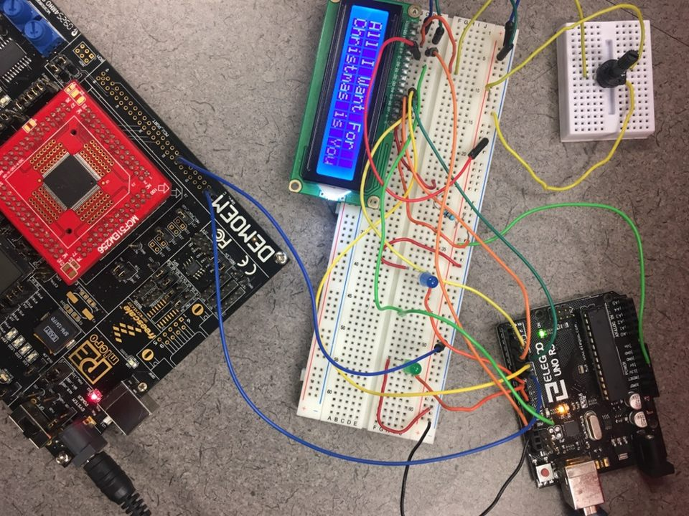

The programming aspect of the design consist of Java code which translated a mp3 file into parts which are usable for the series of LEDs and voltage output for the DEMOEM board. The figure below illustrates the path the song takes as it is transformed from a digital signal into the incredible light display seen by those watching. First the song goes to the process.exe (beat listener code), which finds all the drum kicks, snares, and hat beats which occur in the song. This is then given to the beat writer which writes the signal and the correct length the light should be on. This is what does the bulk of the work in this program. Finally this signal then goes through the Arduino to the LED for the snares and kicks and the hat is outputted via necessary voltage to the DEMOEM board which then handles the lighting of the LED and the counting of the occurrences.

FIGURE 6. Software Flow

Process.exe (Java open source library)

Music file (.mp3)

Arduino (Minim & Fermata libraries)

DEMOEM (CodeWarrior developed code)

## *Results*

After all of our persistent hard work, we have produced a product that is able to pulse based on the analog input coming from some sort of music. The beauty of this design is that it works on nearly any song, and analyses the song real time in order to display the best possible light show to the rhythm of the music. The numerous output options and information that is provided to listeners is what makes this project truly unique and allows for each individual to get something wonderful out of this simplistic embedded system.

The deadline was quickly approaching when the product was completed. There were several difficulties, but the product worked as expected. The team rose through adversity to successfully build the light display. There were real challenges and the program did not want to operate. However, after enough persistent hard work, the bugs that we discovered thus far were eliminated, and we were left with a working embedded system that has the potential to be further utilized outside of our CS594 class project. It felt quite good to deliver a working project solution that has real world utilizations.

## *Discussion*

In the future, we would like to implement larger LEDs that would be much easier to see than the ones used with our current design. The LEDs would most likely have to be connected through some sort of amplifier so that the LEDs would be bright enough. In order to accomplish this, we would need much more than the USB power the system currently runs on. With an external power supply, and the right amplifiers, we could utilize some nice LEDs to flash at the appropriate time.

We were excited to get our product running, but for the most part the lack of LED clarity when playing music was the largest disappointment. For this reason, we would be very interested in pursuing a different method of lighting in the future.

Another possible addition to the embedded system that we designed would be to use the Arduino to continually process the music, the DEMOEM to handle LED coordination and LCD displays, and also have the Arduino connect to the vast music libraries found online via it’s built in Wi-Fi connection to compare music that is being played to that of which is also available online. That way, the embedded system could play music, and also provide recommendations based on the similar songs it finds online.

In terms of delivering a scalable product that has the potential to be marketed, we could most certainly update our solution to meet some of the adjacent markets we mention in the next section. This could be very profitable if done correctly, and at the very least, be rather exciting.

# Adjacent markets and Opportunities

## *Alarm Clock*

While our product is sufficient for music lovers, this system could also be beneficial for many other purposes. With the responsiveness from the music and its beats, this system would be very easy to modify to respond to different kinds of inputs, including an alarm clock. With the heavy sleepers, this system could be very beneficial to them. Since this product responds with lights when an alarm would go off, would offer a much more diverse range of signals to a human in a deep slumber than a regular alarm clock.

Our product would be highly effective as it could be used with any type of musical input and therefore would also be able to use a diverse ranges of inputs for sound, or even the radio, then the system could respond with LED lights to match the rhythm of the input. It could be a potential problem with those who suffer from epilepsy, as this system could cause seizures. But if a person doesn’t have these conditions, this product would be a good way to have a visual and sound way to wake up to.

## *Alerting System*

In a close way to how this would work as an alarm clock, the system that could catch an individual’s eye to alert them could be a huge benefit all over the world. This system would be especially helpful if the user was around loud noises often, such as on a construction site or worked in an environment that was noisy in general. One example, if the alert system happened to be an alarm system in a house, and there was an intruder that got in while there was a noisy environment, the system’s visual display would be sufficient to get attention of the owner, then therefore alert him to the intrusion. When they get alerted, the owner could then be able to do a better check to see what the issue was. While how the individual would react to the intruder would be up to them, the system would just offer them the flexibility of making a choice by alerting them early and doing a good job at getting their attention. This system would add more flexibility and would be a benefit to many who use it.

FIGURE 7. Alerting System Architecture

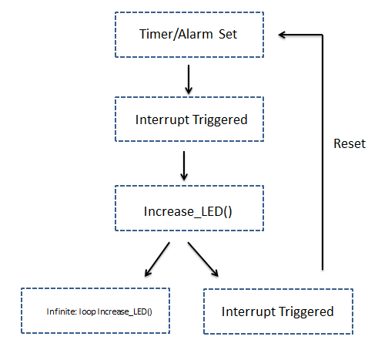

This product would do extremely well for those who have hearing problems, an alert that sounded based on visual blinking lights wouldn’t require any hearing whatsoever. The noise of an alert would usually be sufficient, but in these cases the light display would also be beneficial.

## *Notification System*

Our product would be very beneficial for those who often get notifications from friends and family while in a noisy place or even a quiet place. In an office case, a product which lit up whenever a notification appeared, or someone trying to get in contact with them, would have such an efficient way to get the attention of the user in a quiet workplace. This is very similar to the alert system, and could work in the same way to it. The benefit would be that this notification system could work with less of the sound system and more of a light system. Overall a benefit is that these systems could work on a cell phone even if the phone is on silent mode, these would be a great way to notify the user with visual effects so that they would get the notifications.

## *Housing Lights*

A great way to integrate this system into a real-life scenario, would be to use this system with Christmas lights on a house. With lights flashing to Christmas songs or even a display to show which song is playing would be a great addition to a Christmas light show. Another way housing lights could implement this system would to use this with Halloween to make your house spooky with the songs. A house using this microcontroller will definitely differentiate themselves from the neighboring houses.

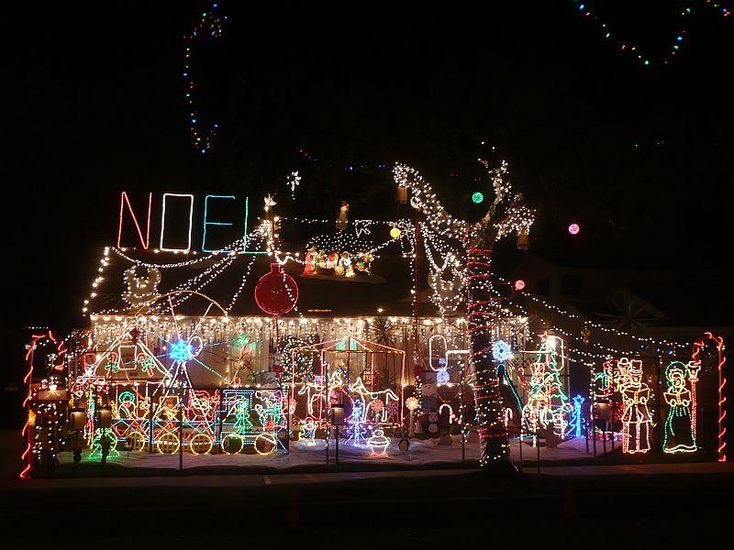

## *Video Game Enhancement*

With these LEDS and display, they could easily program this program with the videogame industry as well. If it was done correctly, then the system would display key information in the direction where it occurred. Where in a shooter video game, if a person would be getting hurt from the left, then a display and light would illuminate from the left side, showing where the action was coming from. This could be easily implemented with extra sensory lights to help with the display, or even to help with high importance events.

# Conclusion

## *Lessons Learned*

After many series of trial and error, we got the program to successfully blink the external LEDs according to a song’s kick, snare and hat and print to the subsequent LCDs as they were supposed to. Through the work we did, we have learned a lot about microcontrollers and the means in which they operate and allow engineers such as ourselves to deliver specified solutions to our world’s solvable problems.

The team was taught an excellent lesson in programming and other useful skills, but also in persistence. In a project, it is often easy to fall behind, or lose track of the end goal as projects can be overwhelming. Having this project come to completion taught the team how hard work can pay off.

Failures are often the tools used for people to learn. Failures can be very beneficial when used correctly, but failing to learn from our mistakes is often a scary path. As no one is perfect, this team knew that it had to rise through adversity in order to finish the goals set before it in a timely manner, and finish with a product that performs well.

## *Open Issues*

We ran into issues when connected to the LED on the DEMOEM board. The most common problem was a varying in brightness of the LED whenever we switched from computer based USB power to an individual 5V battery. This issue is still open and unsolved.

Another issue that we may have is that the song listener references a song placed in a specific folder. Ideally, a script should be written to fetch the music being played by the computer’s onboard speakers or the program playing the music (Spotify, ITunes, etc.) and then parallel process it via the ‘Process’ open source Java library.

An additional complication includes power and making sure that the correct power is sent to power the LED without blowing it up. This requires testing the right combination of LEDs and resistor to ensure nothing faulty occurs as well as making sure the LED shines bright enough to illuminate the surroundings beautifully.

## *Closing*

The project has been a good experience for the team. Through the lessons learned, the adversity faced, and the teamwork required in order to finish, the team has grown considerably.

Through the teamwork, understanding of the Arduino, DEMOEM, and other hardware involved, as well as persistent hard work, the team has produced a quality product. The finished product is not everything it could be, but an understanding of the issues that we faced concurrently as a group is a good step toward finding a scalable solution that solves all of our encountered problems. Someday, we are confident that we could build a light display in order to make many lives better, including our own.

##### References

1. Avni, Amir. "RGB Led Strip Controlled by Filtered Audio Signals Using an Arduino." *What I Made Today*. N.p., 25 Dec. 2015. Web. 11 Oct. 2016. *(references)*
2. Hyrulian. "How to Make LEDs Flash to Music with an Arduino." *Instructables.com*. Instructables, 12 Oct. 2010. Web. 11 Oct. 2016.
3. Motadacruz. "Music LED Light Box." *Instructables.com*. Instructables, 22 Feb. 2010. Web. 11 Oct. 2016.
4. Westfw. "How to Drive a Lot of LEDs from a Few Microcontroller Pins." *Instructables.com*. Instructables, 22 May 2006. Web. 11 Oct. 2016.
5. “Christmas light decorating businesses busy for holidays,” The Washington Post. [Online]. Available: https://www.washingtonpost.com/local/christmas-light-decorating-businesses-busy-for-holidays/2016/12/04/b0112e8e-ba2a-11e6-ae79-bec72d34f8c9_story.html. [Accessed: 04-Dec-2016].